Daily 5 + Writing Lesson Plans
Week 2
Day 6 – Monday, August 20, 2012
Focus Lesson
Review I-Chart “Where to Sit in the Room,” practice again.
One-minute review of “Three Ways to Read a Book.”
Read to Self
Review I-chart.
Continue “10 Steps to Improve Muscle Memory,” adding 1-2 minutes to stamina.
Closure, sharing, and review of the lessons of the day “What did we learn?”
Materials: chart paper, something to signal children to gather (chimes, bell, etc), book boxes, charts from previous lessons
Writing
Mini Lesson
EQ: How do I see myself as a writer?
The teacher and students will discuss the parts of a writer and why they are important. Teacher will then share characteristics of how they see themselves as a writer. Model how to complete “My Writing Life Survey.” Before you give students the survey, you will model completing the survey for the students using a document camera or whiteboard. Read each question and think aloud about how you would answer the question. Jot down some of your ideas. For example, if you were answering question number two on the survey, you might mention specific times when you write lists, letters, etc.
Independent
Students will complete “My Writing Life Survey.”
Tell students that you want to find out about their writing lives so you are going to give them a survey to help you get to know them as writers. Ask students to go to their seats. Give each student a copy of the survey. You will need to guide students

Day 6 – Monday, August 20, 2012 (continued)

through completing the survey by reading one question at a time and giving students an opportunity to respond before moving on to the next question.

Summary
Teacher will compliment students and will state specific examples of what students did well. Two to three students will share their life surveys. Review the Speaking and Listening standard you “unwrapped” with students in the reading session. Ask students to talk about their writing survey with a partner by sharing one of the answers to the questions on the survey. Review with students that they are a community of writers who all know a lot about writing already! They will have the opportunity to grow as writers this year and share their writing with their class.

Day 7 – Tuesday, August 21, 2012
Focus Lesson
Quick review of anchor and I-charts from each day:
“Three Ways to Read a Book”
“Where to Sit in a Room”
“Read-to-Self Behaviors”

Read to Self
Continue “10 Steps to Improve Muscle Memory,” adding 1-2 minutes to stamina.
Closure, sharing, and review of the lessons of the day “What did we learn?”
Materials: chart paper, something to signal children to gather (chimes, bell, etc), book boxes, charts from previous lessons
Writing
Materials: Writing, Chart paper for “What do writers do?” chart, Read aloud (Author by Helen Lester, Arthur Writes a Story by Marc Brown or another book in which the character is a writer)
Mini Lesson
EQ: What do GOOD writers do?
We discussed what readers do, now we are going to think about what writers do. To help us think about what writers do, we are going to read a story.
Choose a read aloud to read to students which involves the character writing a story or sharing an experience as a writer. Author by Helen Lester is an excellent choice because it talks about her journey as a writer. (Other possible read alouds include Arthur Writes a Story by Marc Brown or You Have to Write by Janet S. Wong and Teresa Flavin). Tell students that as you read, you want them to think about the struggles the author had to go through as well as the accomplishments
of the author. After reading the story, you may say something like, “There are so many things we can learn from the character and his/her journey to become an
author. We learned that writing may be hard sometimes and our ideas may not come right away. When we keep at it and work to make our writing the best it can be, we are real writers, just like the character.”
What do writers do?
They make lists.
They write every day.
They add pictures.
They go back to their writing to make it better.
They read a lot.

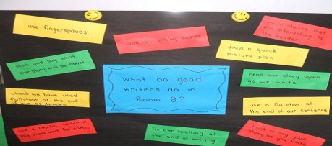

Daily 5 + Writing Lesson Plans
Week 2
Day 7 – Tuesday, August 21, 2012 (continued)

Independent
Students will sit quietly and highlight areas they need to work on and create writing goal.
Summary
Teacher will compliment students and state specific examples of what students did well. 2 to 3 students will share their writing goals.
Review the Speaking and Listening standard you “unwrapped” with students in the reading session. Ask students to talk about their writing goals with a partner by sharing one of the answers to the questions on the survey. Review with students that they are a community of writers who all know a lot about writing already! They will have the opportunity to grow as writers this year and share their writing with their class.

Daily 5 + Writing Lesson Plans
Week 2
Day 8 – Wednesday, August 22, 2012

Focus Lesson

Teach how choose Good Fit Books words (see pages 29-33)
Create I-chart “I PICK.”
- I Choose a Book
- Purpose – Why do I want to read it?
- Interest – Does it interest me?
- Comprehend – Am I understanding what I’m reading?
- Know – I know most of the words.

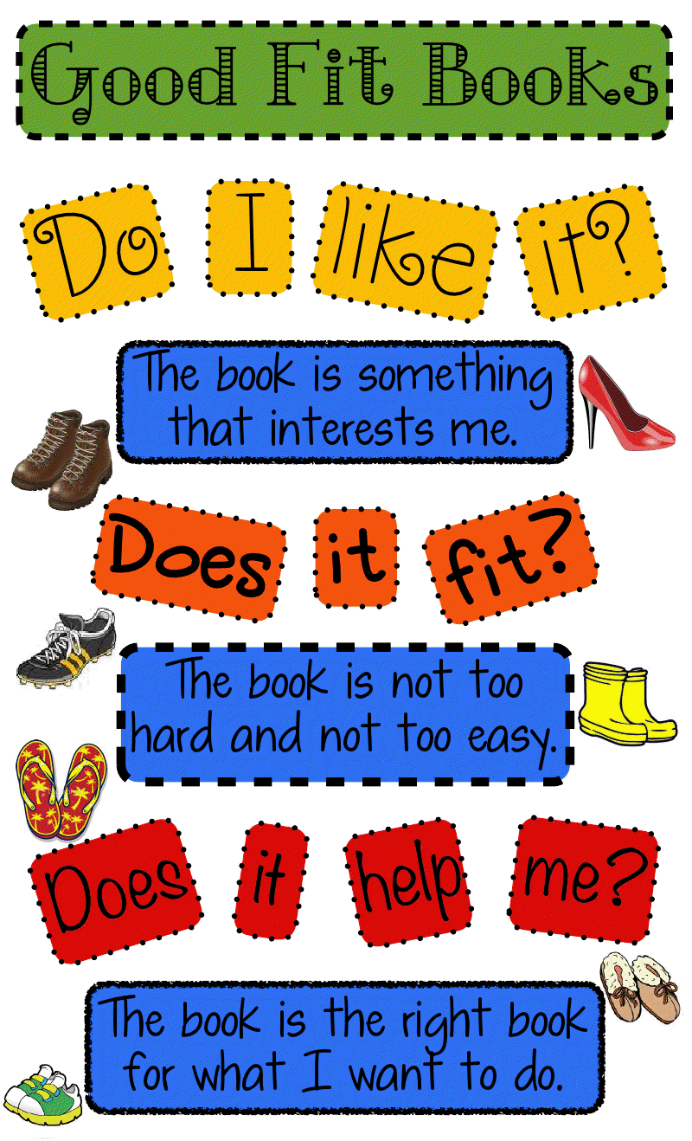
Read to Self

Quick review of Read to Self chart.
Continue to use “10 Steps to Improve Muscle Memory,” adding 1-2 minutes to stamina.

Work on Writing (Daily 5) – Focus Lesson
How to Write Words You Can’t Spell

Introduce Work on Writing. Use 10 Steps to Improve Muscle Memory.”

Setting Purpose for the Day
Sense of Urgency for Work on Writing (chart)
- Become a better reader and writer.
- We care about writing and the people who read it.
- Choice of what to write about
- It is fun.

Model writing, showing what to do during writing when you can’t spell words – underline and go on.

Daily 5 + Writing Lesson Plans
Week 2

Day 8 – Wednesday, August 22, 2012 (continued)

Brainstorm Work on Writing Behaviors:
Students:
- Write the whole time
- Stay in one spot
- Work quietly
- Choice of what to write
- Get started quickly
- Underline words we’re not sure how to spell and move on.

Teacher:
- Work with students.

Correct/Incorrect Model (same as Read to Self)

Building Stamina – Practice
Teacher stays out of the way of children’s reading (no eye contact or managing by proximity at time; Teacher may practice sitting at the guided reading spot.)

Signal and Check In – “How did it go?”

Review I-chart.
Model again if time allows (repeat above steps) – 1-2 students will practice appropriate and inappropriate behaviors, always ending in appropriate behaviors.

Building Stamina – Practice

Signal and Check In – “How did it go?”
Review I-chart.
Closure, sharing, and review of the lessons of the day “What did we learn?”
Materials: notebook paper, book boxes, charts from previous lessons, something to signal children to gather (chimes, bell, etc),
Daily 5 + Writing Lesson Plans
Week 2

Day 8 – Wednesday, August 22, 2012 (continued)
Writing
Mini Lesson
Writers Write from Their Hearts
Notes
- The lesson tomorrow introduces students to a Writer’s Notebook. If the notebook you choose for students to use does not have pockets, you may wish to introduce students to writing folders today. They will need a place to store the heart maps they create.
Materials
- Blank heart maps for students or paper for student to create their own heart maps
- A sample of the teacher’s heart map
- The Best Story by Eileen Spinelli (or another personal narrative read-aloud)

Signal students to come back to the meeting area. Today during our reading time together, we created agreed-upon rules for speaking and listening. We are going to practice these rules during our writing time as we share ideas for writing with each other.
Tell students that today you are going to help them discover where writers get ideas for their stories. Let them know that you are going to read a book to help them think about how writers “wake up their stories” or get ideas. Read a story to spark students’ ideas for writing. It could be any personal narrative in which the author has written about an experience that happened to him/her. (The Best Story by Eileen Spinelli is a great choice because the character is a little girl who is looking for ideas for her story, and her mother tells her that the best stories come from the heart.) After reading the story, discuss where the author may have gotten the idea for the story.

Daily 5 + Writing Lesson Plans
Week 2

Day 8 – Wednesday, August 22, 2012 (continued)

Tell students that a writing community is made up of writers who share and listen to each other’s stories and ideas. Point out that writers often write about the people, pets, and places that are in their hearts.
The people in your heart can be family members, friends, or anyone else who makes you feel special and loved. When you think about the places in your heart, picture places that you love to be, places that are fun, and places that make you feel comfortable and safe. It could be a vacation place or at home.

Tell students that they are going to create a heart map to help them remember the special people and places they can write about. Show students your heart map and share the people and places that are close to you. (You may also choose to model and invite students to include “things they do in their spare time” and “favorite memories” on their heart maps.)
Tell students that you want them to use the agreed-upon rules for speaking and listening to share the people and places in their hearts with a partner. Review the Speaking and Listening standard and the agreed-upon rules that students created.
Ask students to sit quietly and think about the kinds of things they might put on their heart maps. Have them turn to a partner and share three things that they will put on their heart maps. Remind students that they will include many more things.
Before sending students to their seats, review the expectations for independent time.
Independent
Students begin designing their heart maps. Teacher circulates and confers with students as needed.

Daily 5 + Writing Lesson Plans
Week 2

Day 8 – Wednesday, August 22, 2012 (continued)

Summary
This would be a great day to introduce the author’s chair. You will want to develop a system to ensure that every voice has an opportunity to share in a one-two week period. One option is to create a visual to display in the share area. This might simply be a chart with students’ names with a place to put a checkmark when students share. Another option is to put Popsicle sticks with student names in a can and draw out one or two names each day. (If a child chooses not to share, choose another child.)
Before inviting 2-3 students to share their heart maps, review the agreed-upon rules for speaking and listening. Explain that the students who sit in the chair have a very important role, but the audience’s role is just as important. Discuss audience etiquette for listening to the speaker.

Daily 5 + Writing Lesson Plans
Week 2

Day 9 – Thursday, August 23, 2012

Quick review of “Choosing Good Fit Books” chart.

Read to Self
Quick review the Read to Self I-chart.
Continue building stamina and developing independence.

Work on Writing (Daily 5) – Focus Lesson
Review Work on Writing I-chart.
Use “10 Steps to Improve Muscle Memory,” adding 1-2 minutes to stamina.

Closure, sharing, and review of the lessons of the day “What did we learn?”

Materials: notebook paper, book boxes, charts from previous lessons, something to signal children to gather (chimes, bell, etc),
Writing
Mini Lesson
Introduction to the Writer’s Notebook
Notes
The following short clip gives teachers an overview of the Writer’s Notebook. http://www.youtube.com/watch?v=fQEonEcBpaQ&feature=relmfu/www.youtube.com/watch?v=fQEonEcBpaQ&feature=relmfu
Nothing Ever Happens on 90th Street by Roni Schotter is a great book to read aloud prior to the lesson. It is about a girl who keeps a Writer’s Notebook.
There is no wrong way to organize notebooks!
Decide which type of notebook you want your students to have for their Writer’s Notebook (composition book, spiral notebook, 3-ring binder, two-pocket folder,
Daily 5 + Writing Lesson Plans
Week 2

Day 9 – Thursday, August 23, 2012 (continued)

etc.).
It could be divided into sections with a tab divider for each section (Works in
Progress, Conference Notes, and Writer’s Tools or Writing Topics, Practice Pages, and Conference Notes/Reflection).
It could be a 3-ring binder; hole punch a two-pocket folder, and include it in the binder. (As depicted in the website http://teacherweb.com/SC/bells/madden/apt4.aspx).
Amiee Buckner in Notebook Know-How suggests her students begin their daily entries in the front of their notebook working page by page to the back; while at the same time they are asked to write the mini-lessons and strategies taught during Writing Workshop starting in the back of the notebook and working their way to the front.
Whatever the notebook set up you would like in your students’ Writer’s Notebook, model yours the same.
Decide how you want your students to maintain their notebooks. Where do you want to keep them? Will the students personalize the cover? How often will children write in them? Will they take their notebooks home? In addition, you will want to teach them other procedures such as dating each entry and skipping lines.
The following links provide information about Writer’s Notebooks:
http://www.choiceliteracy.com/public/936.cfm
http://hill.troy.k12.mi.us/staff/bnewingham/myweb3/Writer's%20Notebook.htm –
(You may choose to show the notebook before and after pictures to the students.)
Materials
Teacher’s Writer’s Notebook with entries to share already completed, Some type of notebook for each child (marble composition notebooks work well)
Daily 5 + Writing Lesson Plans
Week 2

Day 9 – Thursday, August 23, 2012 (continued)

Chart paper for creating the chart, “In our Writer’s Notebooks we can…”, A Ziploc bag for each student
Begin by sharing the following (this is just a sample, please use wording that is most comfortable to you to support the purpose of the lesson): So far, the activities we have been doing in Writing Workshop have helped you start living like a writer. You learned that writers tell their stories to others and writers get ideas from their hearts - the special people and places in their lives. As you start living life as a writer, you will notice that all of a sudden, you see things like you’ve never seen them before. You listen for sounds and words that strike you. You wonder about things and question why things are the way they are. When you live life as a writer, you may develop a little voice in your head that says, “Write that down.‟ When it happens, you’ll want to write down your ideas and thoughts, so you don’t lose them. You want to capture and write your ideas in a place where you can come back to them again and again. This very special place to keep your ideas is called your Writer’s Notebook. It is a very important tool that writers use. Today you will write in your very own writing notebook and practice living as a writer.
Tell students that they will use this notebook throughout the year to collect ideas and practice what they learn about writing. They can keep and record observations, note things they wonder about, record memories and family stories that can become the seeds that grow future writings.
Show students the Writer’s Notebook you are keeping. If you have been keeping a Writer’s Notebook, show the different types of entries you have made. If you are just starting in your notebook, tell the students you will model for the class how you will begin and maintain your notebook.
Begin a chart: “In our Notebooks we can…” Let students know the expectations such as writing the date before each entry. You will continue to add to this chart as you introduce new strategies for writing in the notebook.
In our Writer’s Notebooks we can…
- write stories about the people and places in our hearts.

Daily 5 + Writing Lesson Plans
Week 2

Day 9 – Thursday, August 23, 2012 (continued)

We used the heart map to help us think of the special people and places in our lives. We are going to use our maps to wake up stories in our minds. I am going to show you how I choose a special person from my heart map and think of something I did with this person. Then I will tell you my story. Model choosing a special
person from your heart map.
Tell students that before you tell your story, you are going to look at the Speaking and Listening standard introduced previously to make sure you include what is expected. Show and review the Speaking and Listening standard ELACC2SL4: Tell a story or recount an experience with appropriate facts and relevant, descriptive details, speaking audibly in coherent sentences. Discuss the meaning of the standard and provide synonyms for unfamiliar words such as relevant and coherent.
Model thinking aloud about some things you did with that person, choose one idea, and then tell a story about your time with that person.
Model setting up a page in your Writer’s Notebook. Write the date at the top. Begin with a sketch of your story. (Make sure you emphasize that a sketch is a quick drawing and that the majority of writing time should be spent writing.) Then begin writing a few lines of your entry, demonstrating how to skip lines and showing the students how you can write the story you just told! Add “write stories about the people and places in our hearts” to the chart.
Tell students to get out their heart maps and choose one person on the map. Ask them to think of something they did with that person –a story of a time with that person. Ask students to take turns telling their stories to their partners. Remind them to make sure they are including relevant and descriptive details and speaking audibly. Remind the partner who is listening that it is his/her job to listen. If something does not make sense or if he/she thinks the storyteller has left something out, the listener will need to ask his/her partner for clarification.
Tell students that whenever they need an idea to write about, they can think of a
Daily 5 + Writing Lesson Plans
Week 2

Day 9 – Thursday, August 23, 2012 (continued)

time they had with a special person. Encourage students to write a short entry in their notebooks about the story they just shared with a partner. Tell them they can sketch first, if it will help them. Remind them to write the date at the top of their entry.
Independent
Students will write and the teacher will circulate around the room and observe students as they are writing. Meet with students who seem stuck, and remind them they can write what they just shared with a partner.
Summary
IMPORTANT HOMEWORK! As writers, we are ready to start using our notebooks! We need to decorate them to make them very special. Tomorrow we will be decorating our notebooks, so this evening I want you to think of materials you can bring in to decorate the covers and backs of your notebooks. The materials can be anything from special pictures, fabric, magazine cut-outs, handmade decorations, ribbon, to awards— basically anything that has meaning to your life. Your notebook will be very personal, so your cover should reflect you. Put your materials in the Ziploc bag I give you and bring it to school tomorrow. This will be an exciting passage as we move into establishing more habits of the “writerly‟ life!
Ask a few students to share something they wrote in their notebooks.
Share how you have personalized your notebook (e.g., pictures, quotes, colored paper, special lettering). Inform students that tomorrow they will personalize their notebooks, so their homework for tonight will be to gather items to bring to school for this special activity (see below for sample letters to send home). So for homework, they may want to bring in pictures, photos, ticket stubs, quotes they’ve collected, favorite poems, invitations, newspaper clippings, small objects, etc. to include in their notebooks.
Daily 5 + Writing Lesson Plans
Week 2

Day 9 – Thursday, August 23, 2012 (continued)

Find Three Artifacts from YOUR LIFE!
Raid your junk drawers, your closet, or your room.
Look for items that bring back memories: ticket stubs, pictures, postcards, or even candy wrappers. Anything that represents YOU!
**Remember, you are going to be taping/gluing these things into your writer’s notebook. Get permission before you bring items to school!
Due:________

Daily 5 + Writing Lesson Plans
Week 2
Day 10 – Friday, August 24, 2012
Focus Lesson
Quick review of “Choosing Good Fit Books” chart.
Read to Self
Quick review the Read to Self I-chart.
Continue building stamina and developing independence.
Work on Writing (Daily 5) – Focus Lesson
Create I-chart for where to sit in room during Work on Writing.
Review Work on Writing I-chart. Continue building stamina and developing independence.
Closure, sharing, and review of the lessons of the day “What did we learn?”
Materials: notebook paper, book boxes, charts from previous lessons, something to signal children to gather (chimes, bell, etc)
Writing
Mini Lesson
EQ: How do GOOD writers get their ideas?
Writers Get Ideas from Other Writers
Notes
If children have not had an opportunity to decorate their notebooks, you may want to take a little time prior to this lesson to let students decorate their notebooks.

Daily 5 + Writing Lesson Plans
Week 2
Day 10 – Friday, August 24, 2012
Materials
- Writer’s Notebooks
- Heart maps
- Read aloud to spark ideas for writing such as Fireflies by Julie Brinkloe
- Chart started the day before - In our Writer’s Notebooks we can…’
In our Writer’s Notebooks we can…
- write stories about the people and places in our hearts.
- write ideas we get from other writers.

Review that yesterday students learned about the special tool writers use – the Writer’s Notebook. Refer to the chart you began yesterday. Praise students for the wonderful stories they told and began writing about the people from their hearts. Tell them that today they will continue to tell and write stories.
Tell students that since they will have another opportunity to tell a story to a partner you are going to review the Speaking and Listening standard ELACC2SL4: Tell a story or recount an experience with appropriate facts and relevant, descriptive details, speaking audibly in coherent sentences. Discuss the meaning of the standard.
Tell students that you are going to share with students another way writers come up with ideas for their stories. Writers get ideas from other writers. Add this to the “In our Writer’s Notebooks we can” chart.
Read a mentor text such as Fireflies. (Typically, you will NOT read a book during Writing Workshop. You will read it during your read aloud time and then revisit it to make your teaching point. Since the purpose is to spark ideas, it is appropriate to read it here.)
After you finish, say to students, “This book reminds me of a time in my life when…” Tell a short story that is connected to the mentor text. Point out how you included the appropriate facts and relevant, descriptive details, and spoke audibly.

Daily 5 + Writing Lesson Plans
Week 2
Day 10 – Friday, August 24, 2012 (continued)
Model how you could write that in your Writer’s Notebook. Add the date, and don’t skip pages. Just write the first few sentences and explain that you would add the rest of your story to complete the notebook entry. Tell them you won’t do that now, because you want to hear their ideas.
Ask the students to turn to their partners and tell a story about something that this book reminds them of. If they struggle with relating to this book, they may choose a person or place on their heart maps and tell a story about it. Remind students to make sure they include the relevant and descriptive details, and speak audibly. Add “write ideas we get from other writers” to the chart.
Tell students that when they go to write today, they can either continue writing the story they started yesterday or write the story they shared with a partner today. If they decide to do that, they will write the date on the next line and continue writing. If they choose to write the story they told a partner, they will go to a new page and write the date. Model the decision you would make and begin modeling how you would continue your story or begin a new story.
Remind students that whenever they are not sure what to write about, they can look at their heart maps and think about a time with a special person or at a special place or write about ideas they get from other writers.
Independent
Students will continue writing the story they started yesterday, or begin a new story about a time in a place they listed on their heart maps.
Summary
Use the agreed-upon signal and gather the students back in the meeting area. Invite a few students to share their notebook entries.
Practice your ritual for students putting away and getting out their Writer’s Notebooks.
Daily 5 + Writing Lesson Plans
Week 2
Day 10 – Friday, August 24, 2012 (continued)
Procedures for needing help during independent reading time:
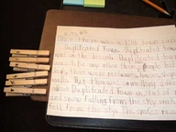
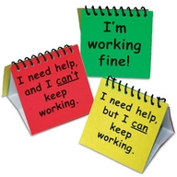

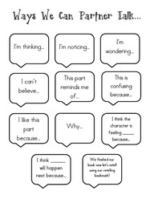
Setting up reading partners:
