Grade 3
English Language Arts
Pre-Unit

August 15, 2012
Mini Lesson | 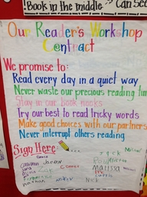  Anchor Chart on the Parts of the Workshop (Pie Chart). Students need to know the 3 parts and understand the transitions. The Focus for today is that Strong readers need to read every day.  EQ- What can I do to become a strong leader?  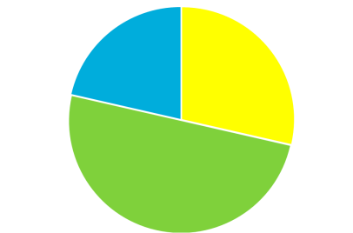
Independent | Students can choose any book to read and sit quietly in their assigned spot to read.
Summary | Strong readers read every day. Teacher will compliment students and state specific examples of what students did well. 2 to 3 students will share their successes.

August 16, 2012
Mini Lesson | Chart what happens during the mini lesson, student responsibilities and teacher responsibilities. Model by reading and asking students questions and having them answer them.
Independent | Students can choose any book to read and sit quietly in their assigned spot to read.
Summary | Review mini lesson and go over anchor chart of student responsibilities.

August 17, 2012
Mini Lesson | Focus on independent reading. Anchor chart on what independent looks and sounds like.  EQ: What does independent reading look and sound like.
Independent | Students can choose any book to read and sit quietly in their assigned spot to read.
Summary | Teacher will compliment students and state specific examples of what students did well. 2 to 3 students will share their successes.

August 20, 2012
Mini Lesson | Review anchor chart on independent reading. Go over important parts of independent reading. Model how to find story elements and post on a sticky notes.  ELACC3RL1. – review story elements
Independent | Students will all be given the same book. Students will be given 3 sticky notes and must find the following: 1. Character 2. Setting 3. Problem/Solution
Summary | Choose 3 students to share their information. Students need to explain how they found the answers.

August 21, 2012
Mini Lesson | 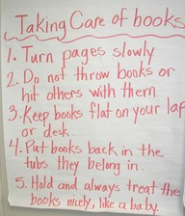  Good readers take care of books. Teacher talks about location of classroom library and types of books to choose. Teach students about book levels and how to choose a book “just right” for them. What to do when you read all of your books.
Independent | 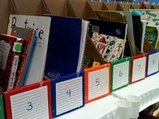  During the independent time students are allowed to look through their independent books and choose a book to read.
Summary | Review “just right” books and review AR and library rules.

August 22, 2012
Mini Lesson | Review anchor chart on independent reading. Go over important parts of independent reading. Model how to find story elements and post on a sticky notes.  ELACC3RL1. – review story elements
Independent | Students will all be given the same book. Students will be given 3 sticky notes: 1. Character 2. Setting 3. Problem/Solution
Summary | Choose 3 students to share their information. They need to explain how they found the answers.

August 23, 2012
Mini Lesson | Discuss reading log and model how to use one. Review story elements and sticky notes.  ELACC3RL1. –story elements
Independent | Students will all be given their reading log to use and also sticky notes to answer story element questions.
Summary | Choose 3 students to share their information. They need to explain how they found the answers.

August 24, 2012
Mini Lesson | SS3H1.a Identify the influence of Greek architecture (columns on the Parthenon, U.S. Supreme Court building), law, and the Olympic Games on the present.  RI.3.1 Ask and answer questions to demonstrate understanding of a text, referring explicitly to the text as the basis for the answers.
Independent | Students will draw and label pictures of the three Greek columns and then use information from their text to describe each column.
Summary | Choose 3 students to share their information. They need to explain how they found the answers.

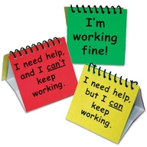
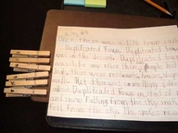
Procedures for needing help during independent reading time

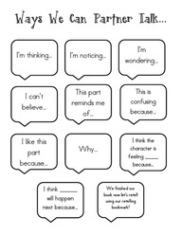
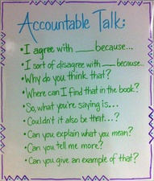
Setting up reading partners

